**096260 - Deep learning course**

**Warm-up exercise**

Submitted by: Danny Semiat 200068807 Sagitt Efrat 200888386

* **Model architecture description, training procedure:**

We normalized the data according to the mean

We have 5 layers in our Neural Network :

Linear(inputSize,64) → ReLU() → Linear(64,32) → Tanh() →

Linear(32,16) → Tanh() → Linear(16,7) → Relu() →

Linear(7,outputSize) → LogSoftMax()

We used 20 epochs and 'nn.ClassNLLCriterion()' criterion.

* **Two convergence graphs**

Error:

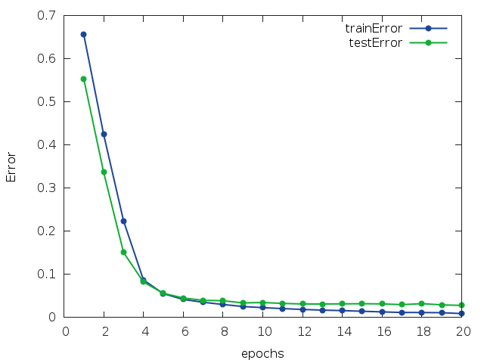

Loss:

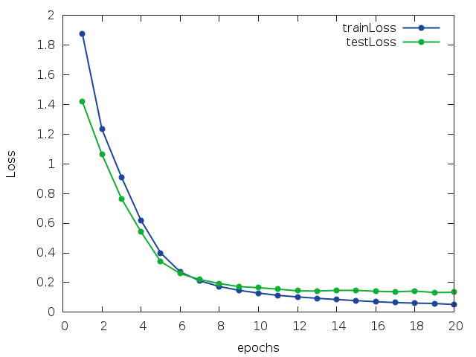

* **A short summary of our attempts and conclusions:**

We tried different kind of variables numbers in the network layers, the number of the layers and also tried different kind of PCA's and then decided on the ones that gave us the lowest loss. The loss function remained 'ClassNLLCriterion' after trying also 'CrossEntrophy' that gave us bigger loss.

The number if epochs was also decided by trial and error.

* **Our code:**

On github repository:

<https://github.com/HolyFalafel/DeepLearning.git>

Under folder:

EX1 - MNIST DB Classifier

classification_mnist.lua - creates the model.

classification_mnist_load_model.lua - loads our trained network and returns the average error on the test set.